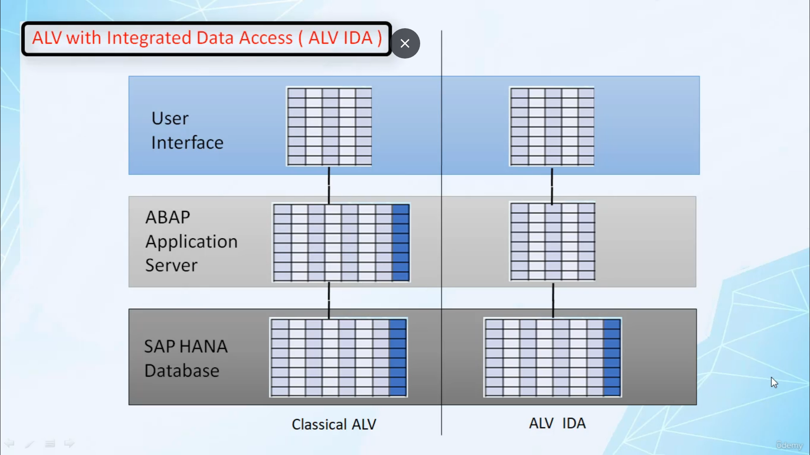

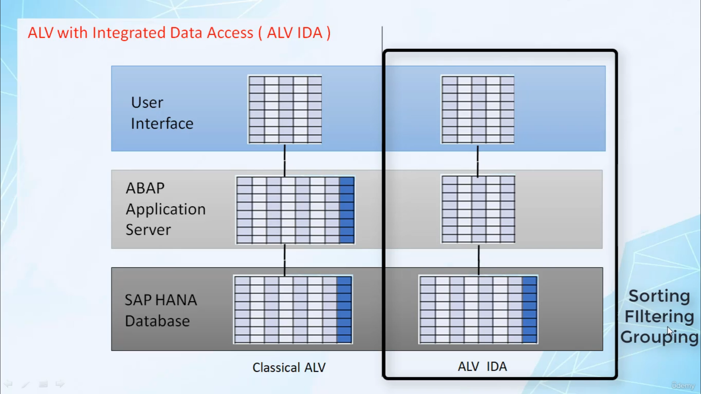

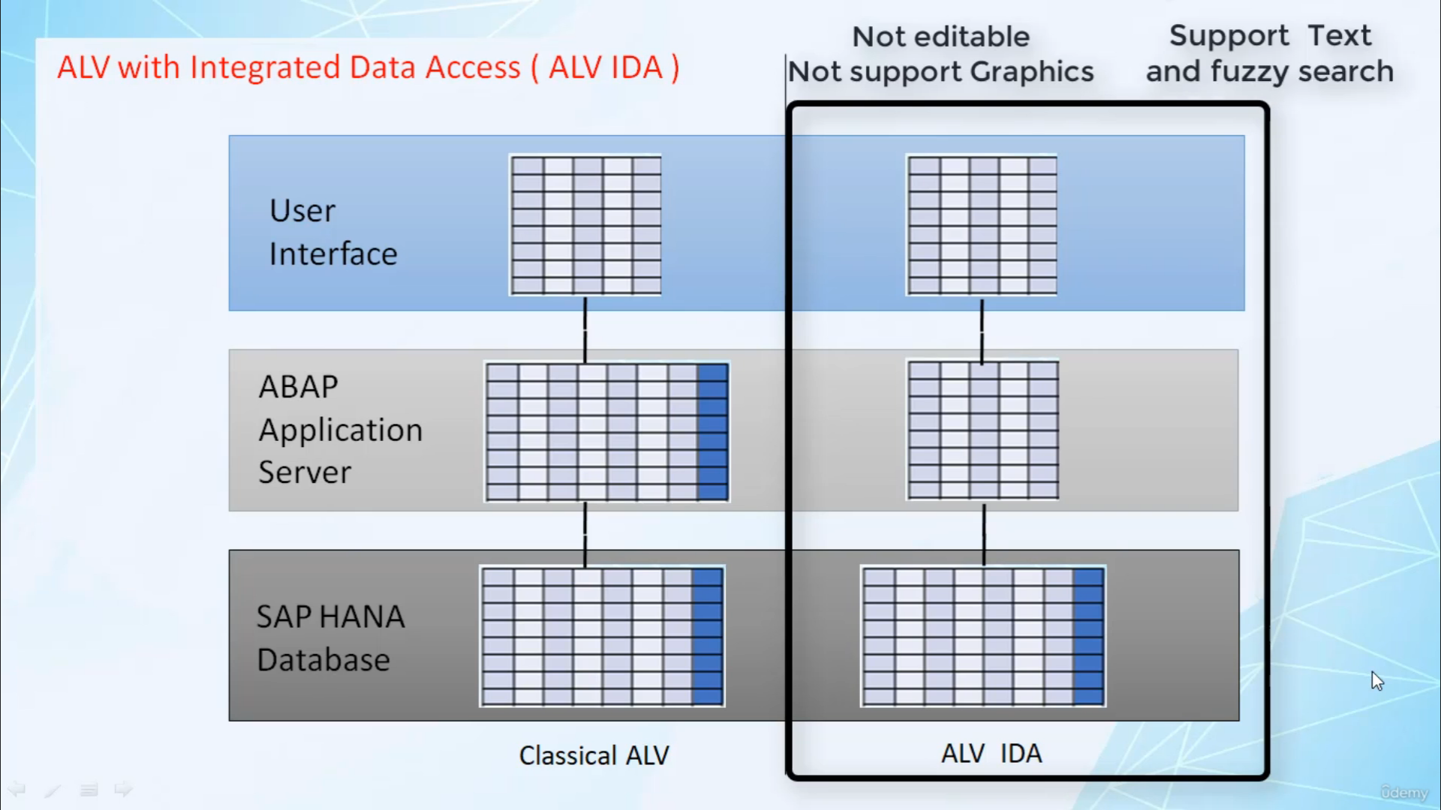

Hi, welcome back.

In this video, I will tell you about Elby with integrated detoxes.

Is it he has designed a special version of LV, the ACP list work Integrated Latex is also known as

Elbit Idea, this version of Elvis optimized for use with a superior database.

LBB Ideals also supports other database, L'viv, Italy offers other developers the option to take advantage

of a Sleepy Hollow without having to present the user with a new or different interface functionality

that has been using the Elvie for a long time, such as the ability to aggregate data are still available

in Italy.

In classical, we approach the application first, perform more traditional check and extract relevant

data from database to internal.

But then the business data, such as calculated philes, can be added into internal content.

After this up information such as icons links must be added.

The Internet is the path to services which then manipulate data according to user requirements and the

recorded ads displayed on the screen.

The problem with classical Elvis in the classical Elvis way requires all data to be first loaded into

intelligible in order to display it, and typically this is larger than what is actually displayed to

the user.

In the end, this initial load can lead to very long waiting time for the end user or short term due

to memory consumption.

Sorting, filtering, grouping, all these processes take place in Hampstead on Internet.

But all this process takes a substantial amount of time.

The idea is based on new principle, where we select only the data in the database that is supposed

to be displayed, that is we apply data filtering in the database so that only a small dataset is returned

to the above stack and pass through more or less unchanged to you.

What?

As a result, the data is retrieved much faster on a sleepy hunter, and you also need far less memory

on abstract.

Authority takes sorting, filtering, grouping and other processes that were previously carried out

by application server are not performed by database.

Hence, there is no longer a need to store the display data inside an internal table, hence resulting

to less waiting times before their display and remote possibility of random error due to memory consumption.

The LBB today will look and feel familiar to end users who have worked with classical LV, but there

are some small differences in functionality.

Again, behavior such as LBA, it is not editable and it doesn't support graphics.

And for this, it is possible in Alvida.

That's it for now.

I hope you understood the.

Have a nice day.